PWS-870 keyboard fail during POST screen
Data Create | 2014/11/06 | Release Note | □ Internal ■ External
Category | FAQ | Product Group | SAG
Function | BIOS USB 3.0 | Related OS | -
Related Product | PWS-870
[Abstract]
Disabling USB 3.0 in BIOS may cause USB keyboards fail in the POST screen. Completely shut down can fix this problem.

[Solution]
Disable USB 3.0 in BIOS, boot to the OS, and then restart. You will find there’s no keyboard detected in the POST screen, which makes it impossible to edit the BIOS settings any further.
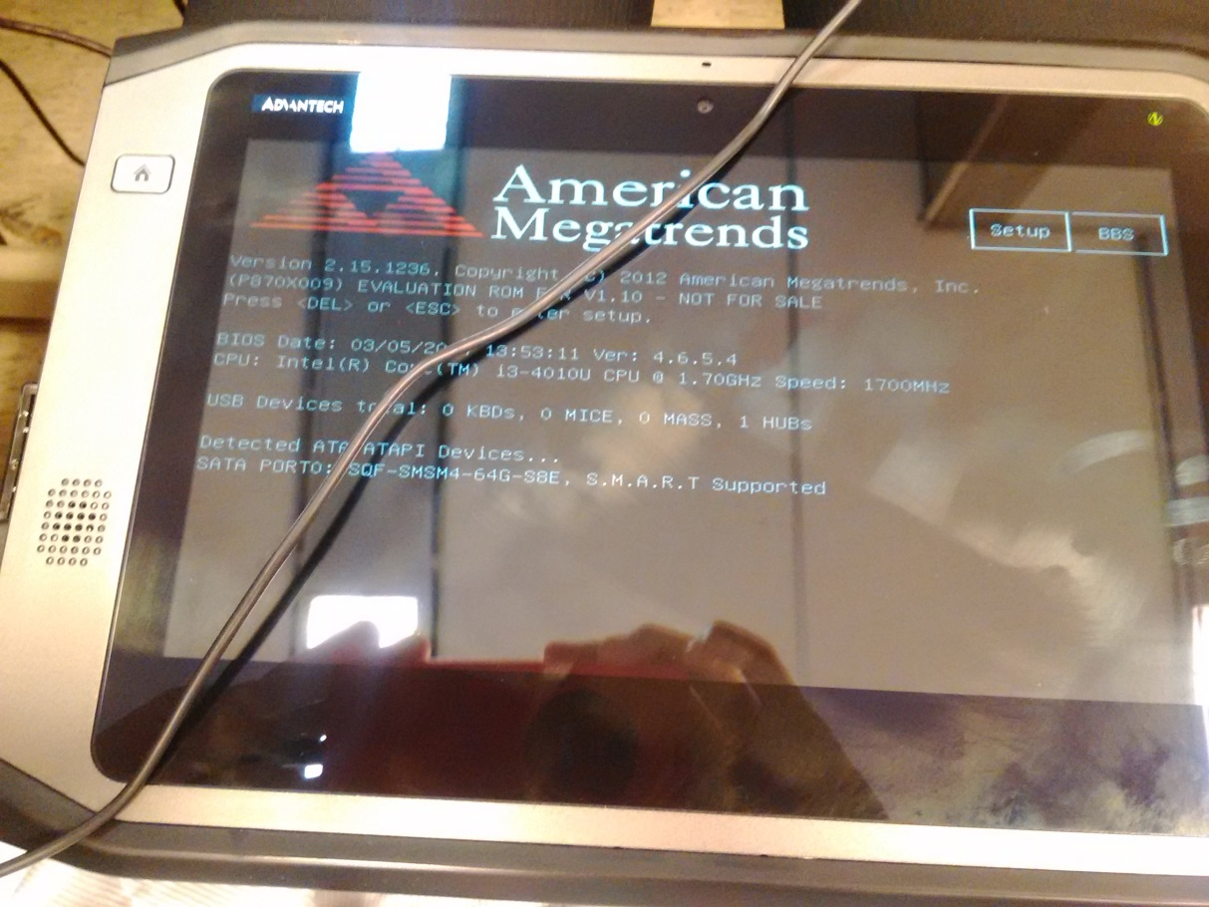

The solution: get into the OS, and shut down (but not restart). The keyboard will come back to the POST screen again. Then go to BIOS and enable the USB 3.0 function.

