Advantech AE Frequently Asked Questions
Data Create | 2014/10/15 | Release Note | ■ Internal □ External
Category | FAQ | Product Group | SAG
Function | IP CAM | Related OS | WES 7
Related Product | TREK-674, EKI-2528PAI

[Abstract]
The IP CAM and the host computer (TREK-674) are connected to the same switch (EKI-2528PAI), but the host cannot recognize the IP CAM.
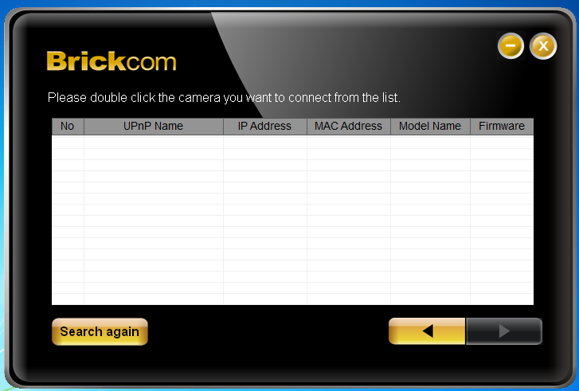

[Solution]
This issue is due to Windows’ Firewall configuration. When “Public network” is applied to the network shared with the IP CAM, Windows will block the host from detecting the IP CAM.
Go to “Control Panel\All Control Panel Items\Network and Sharing Center,” and press the text under the name of the network shared with the IP CAM.
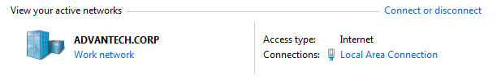
Then change the configuration to “Home network” or “Work network”.
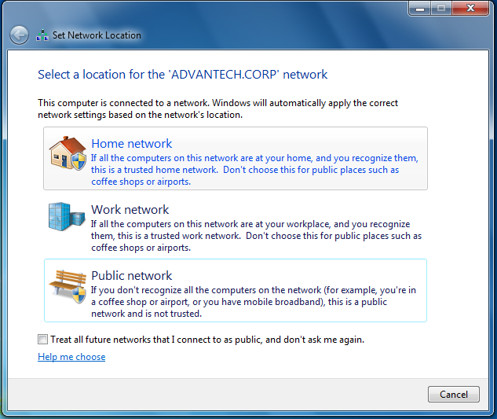
After adjusting the configuration, remove the LAN cable and reconnect it, search for IP CAM again, and you should see it on the list.
